MS Power Automate Flow - How To Import

Version 1.1. Last updated August 24, 2023

# Importing into MS Power Automate

### Step 1

Download **MS Flow .zip file**, provided to you by ADG.



**Step 2**

From the browser, click the **Microsoft Office Suite waffle > Power Automate**.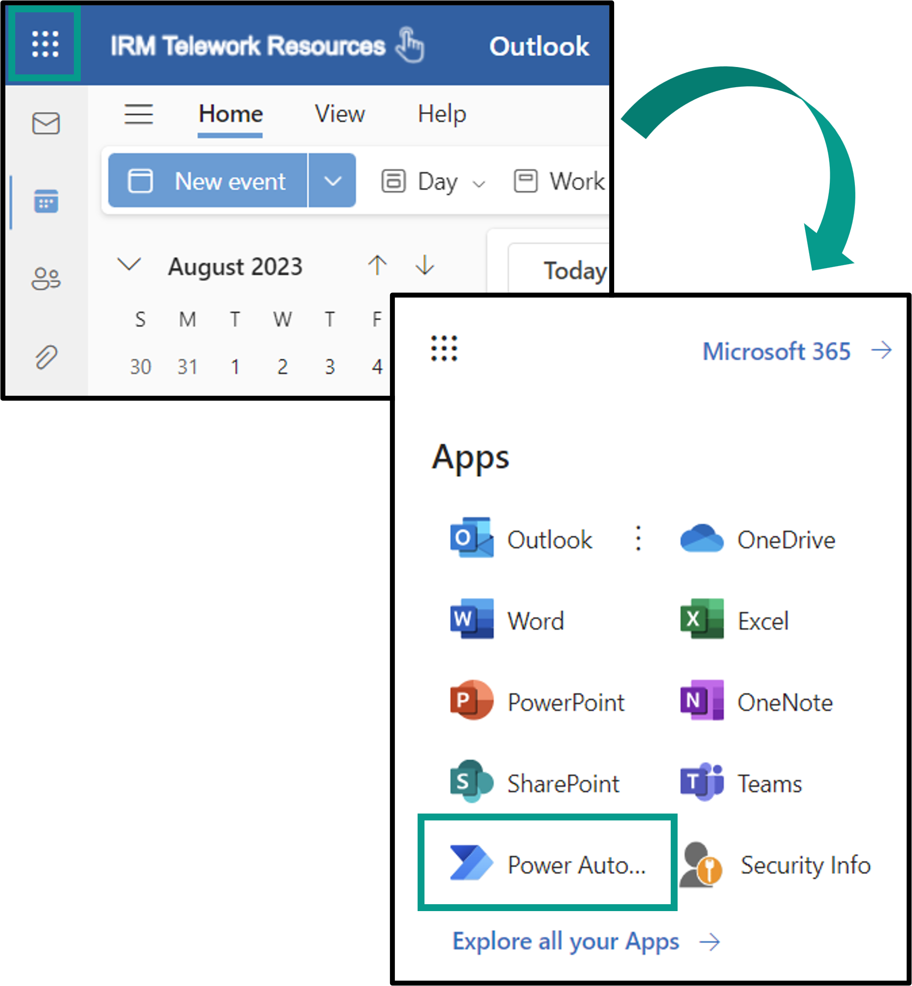

### Step 3

From the left menu bar, select **My flows**.

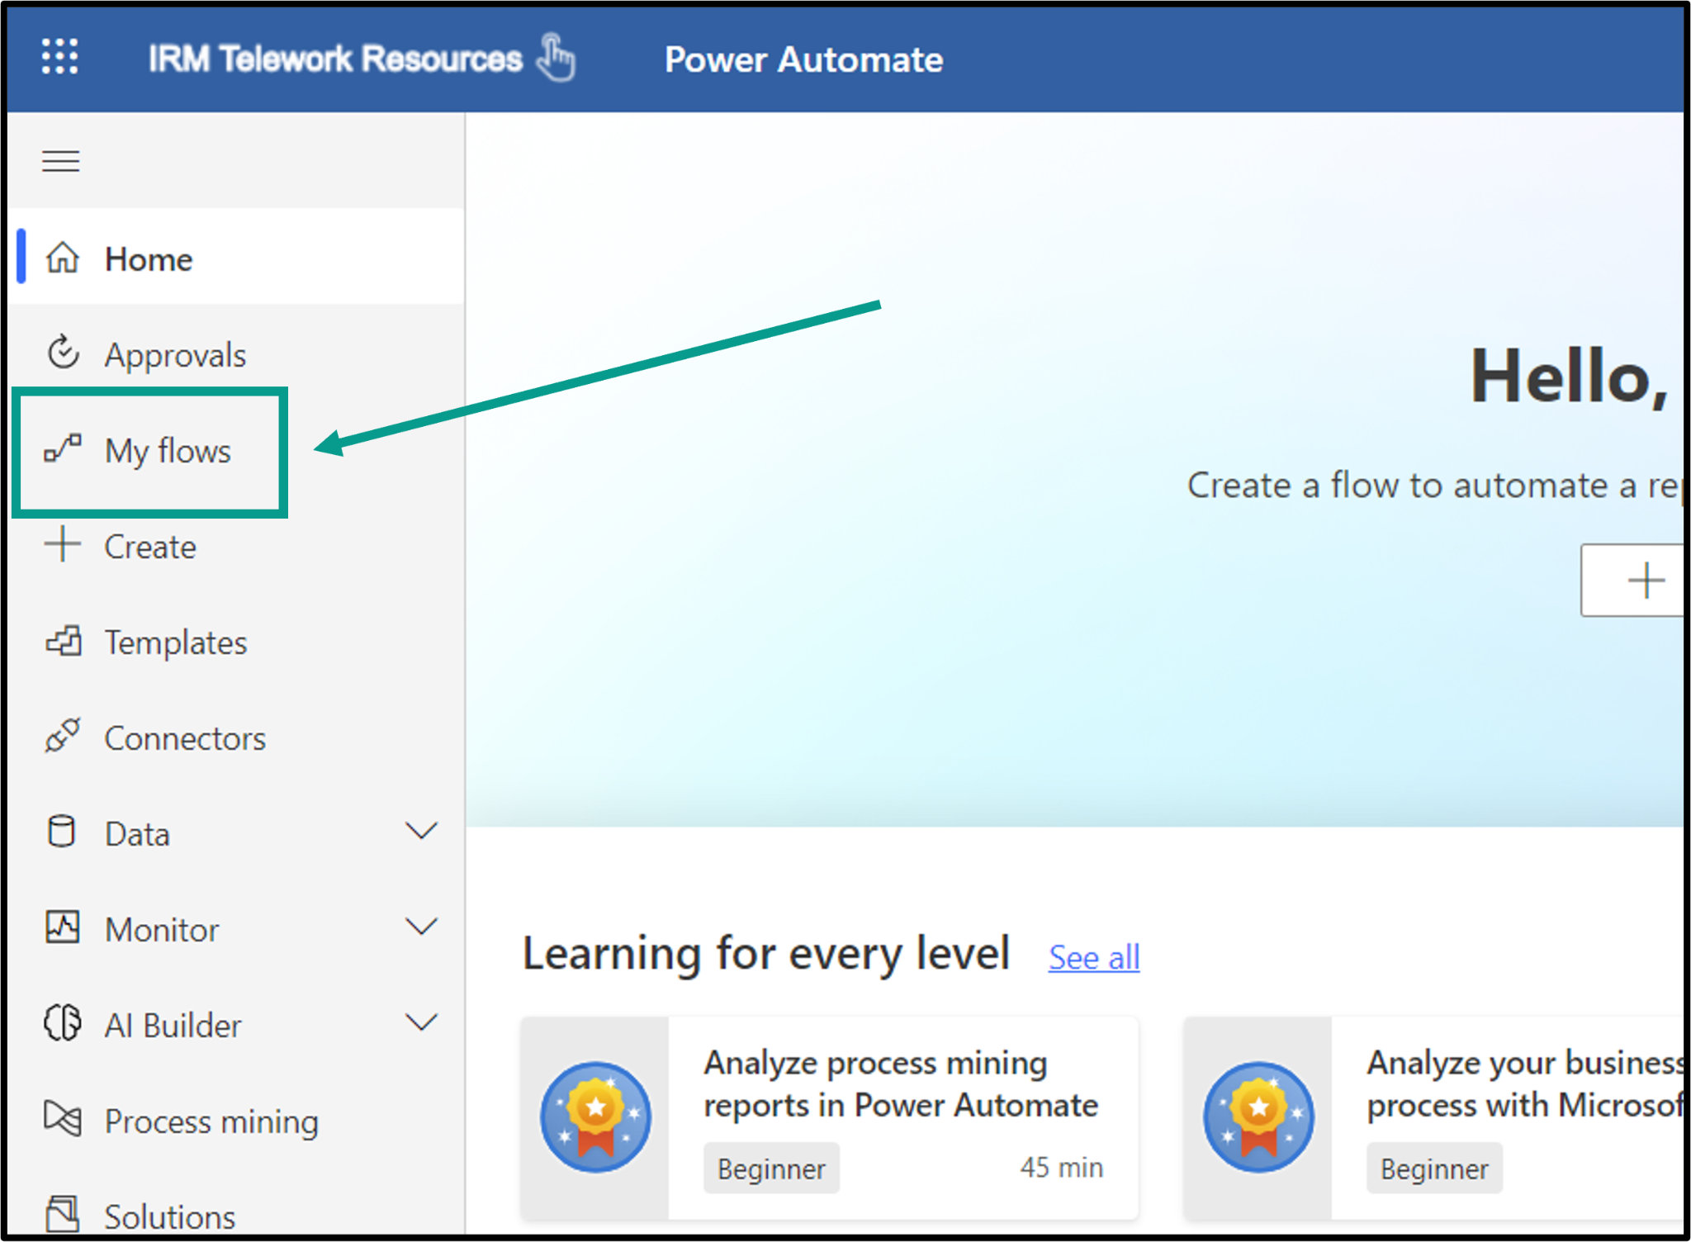

### 

### Step 4

Click **Import**, from the top menu bar and select **Import Package (Legacy)**.

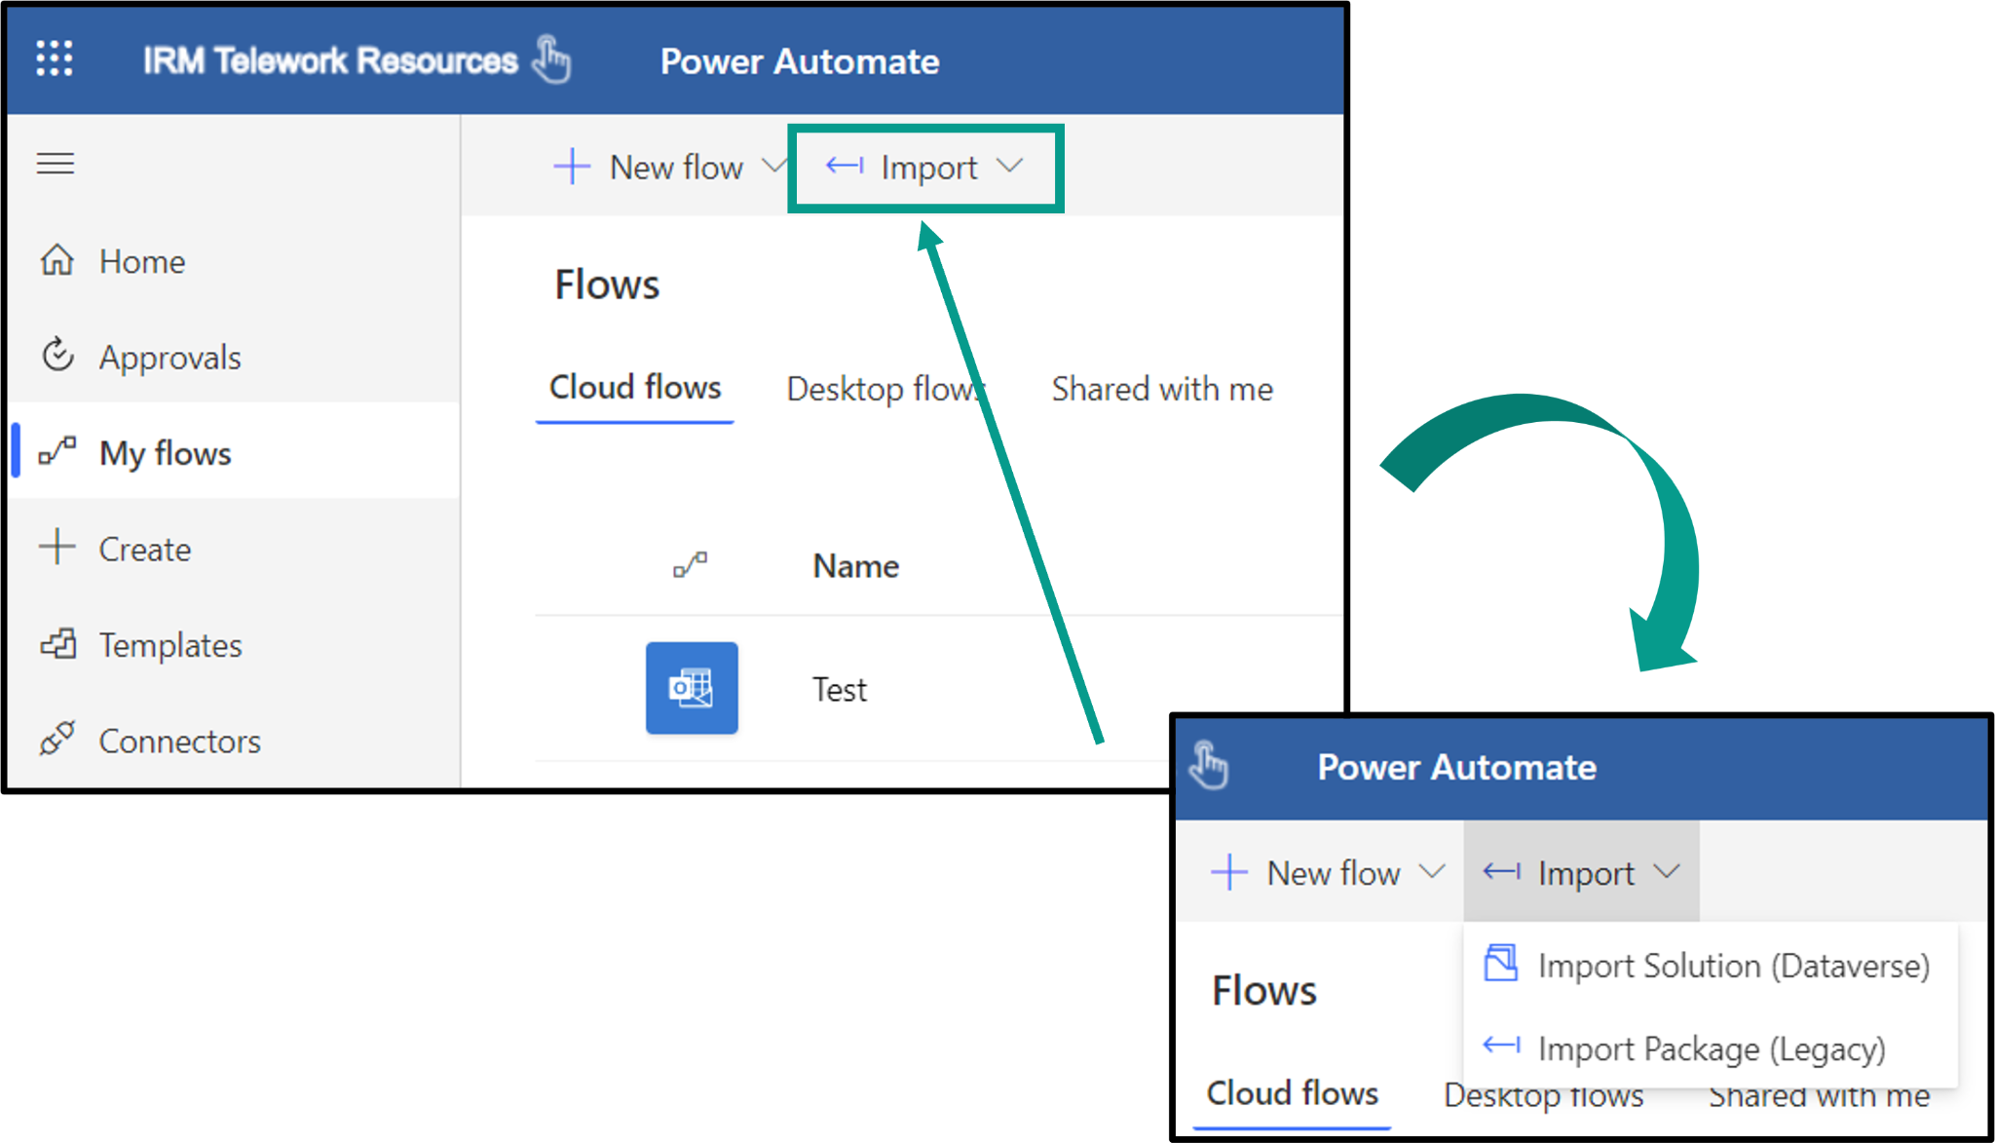

### 

### Step 5

Upload the **Flow file** (the MS Flow **.zip file** from Step 1).

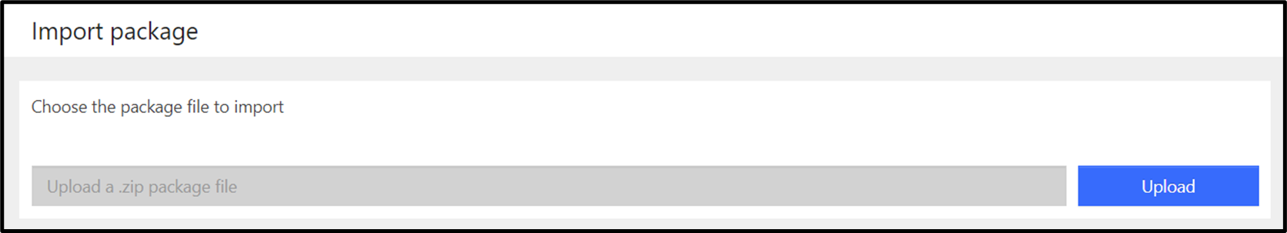

### Step 6

Click the **Action icon**, in the **Choose Your Import Option** section.

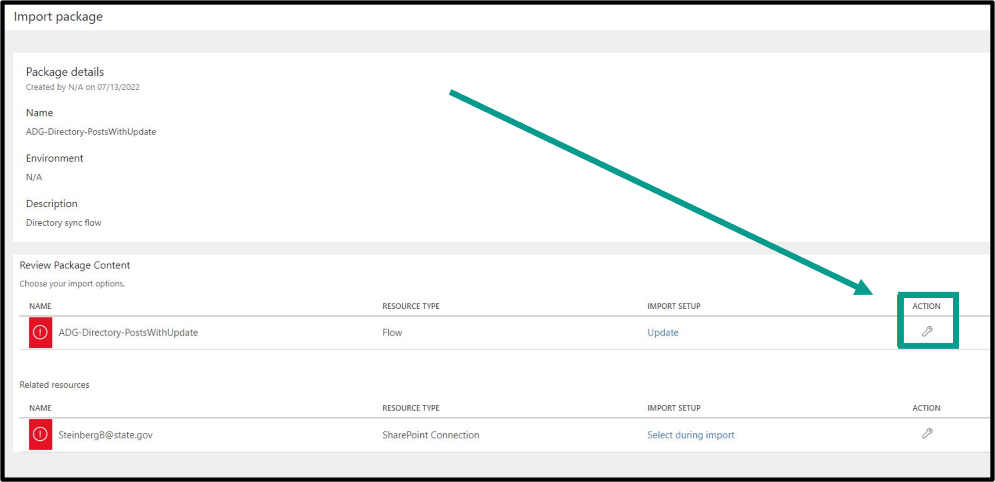

### Step 7

From the Setup dropdown, select **Create as New** and then click **Save.**

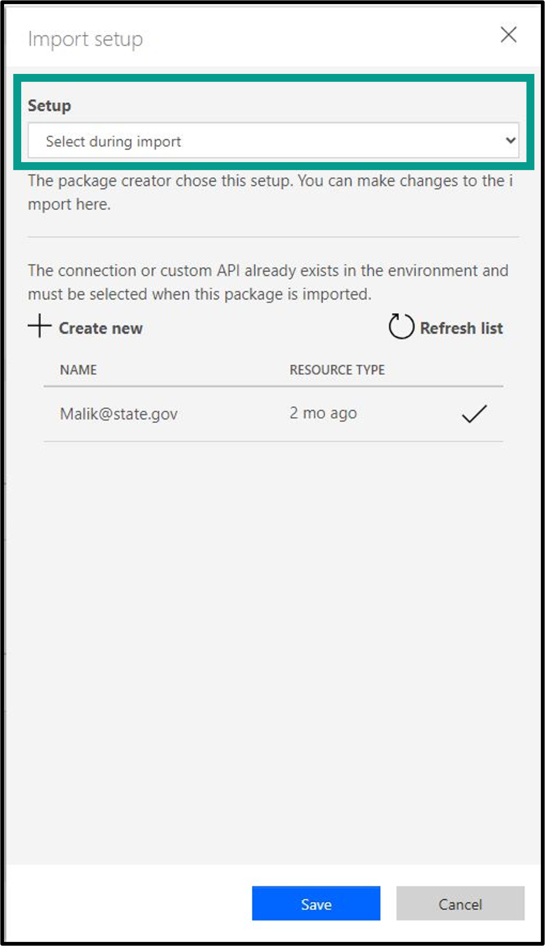

**Step 8**

Under **Related Resources**, select your account and click **Save**.

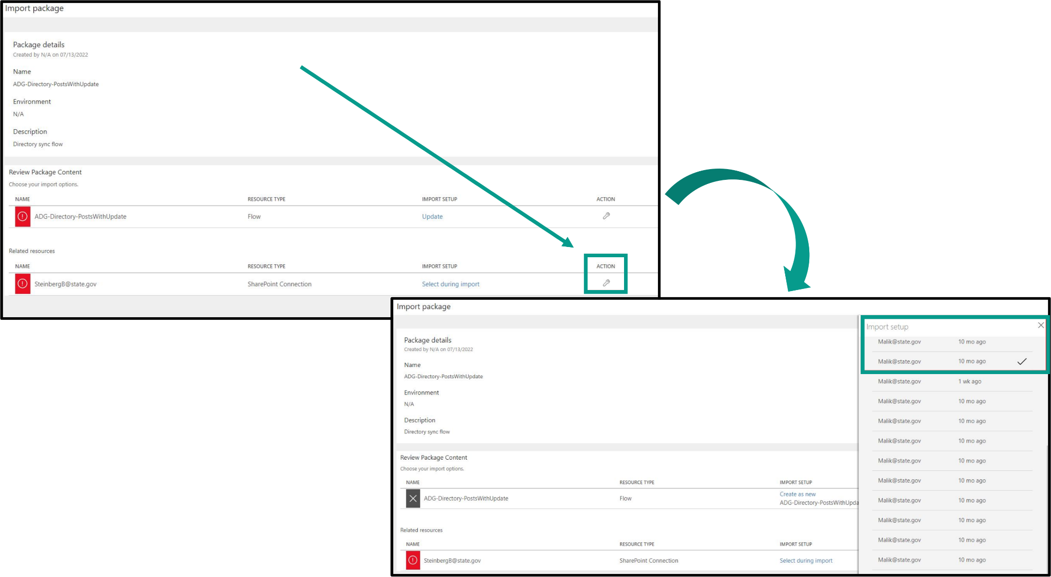

**Step 9**

In the new window, click **Import**.

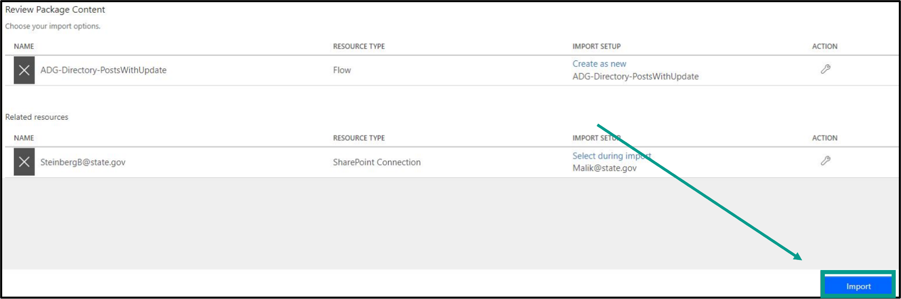

**Step 10**

Once the import is complete, click **Open Flow**.

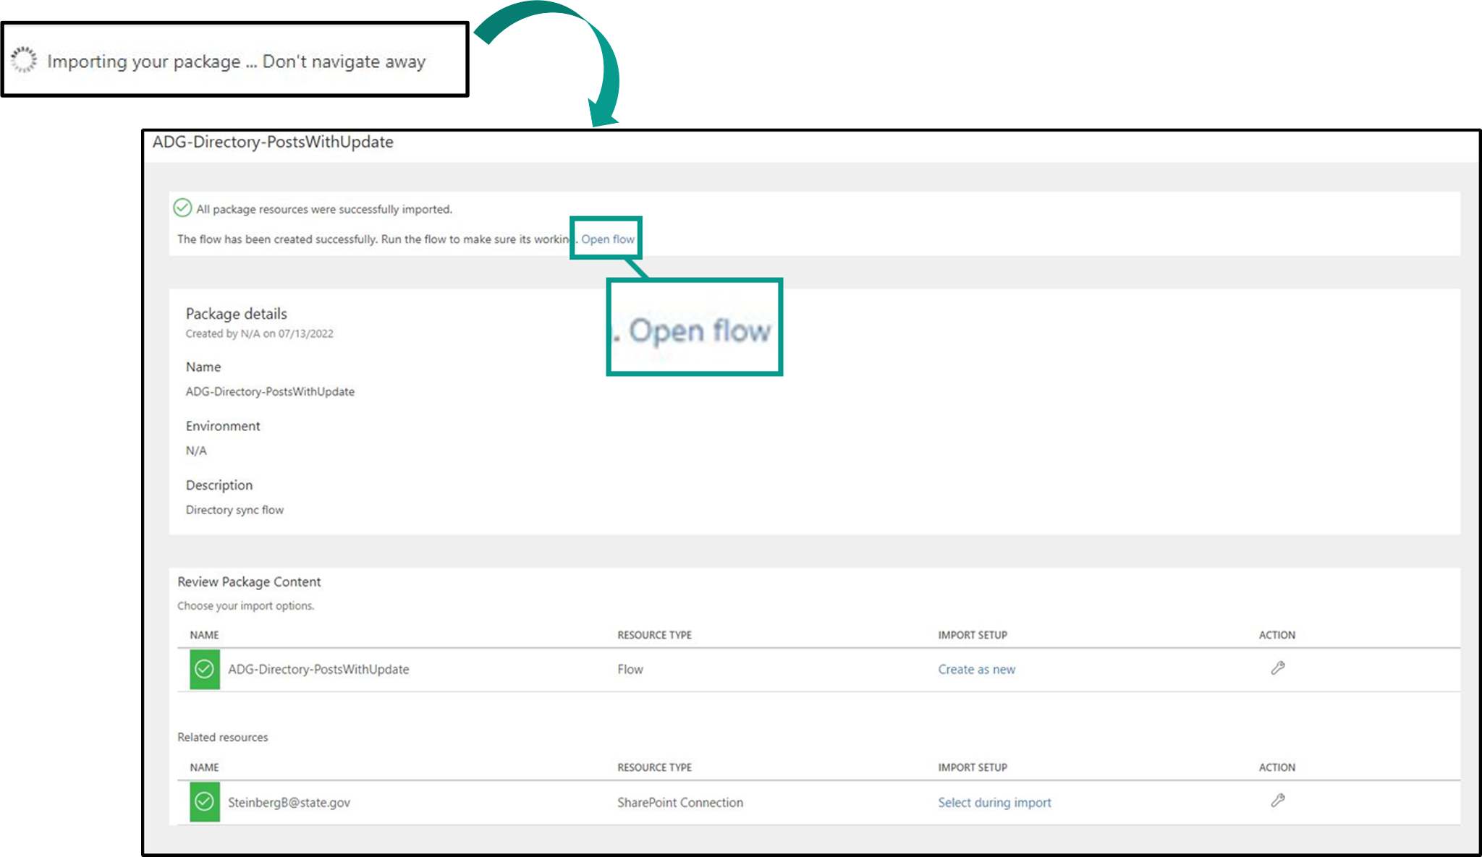

**Step 11**

Under **Destination List URL**, type your Sharepoint site address.

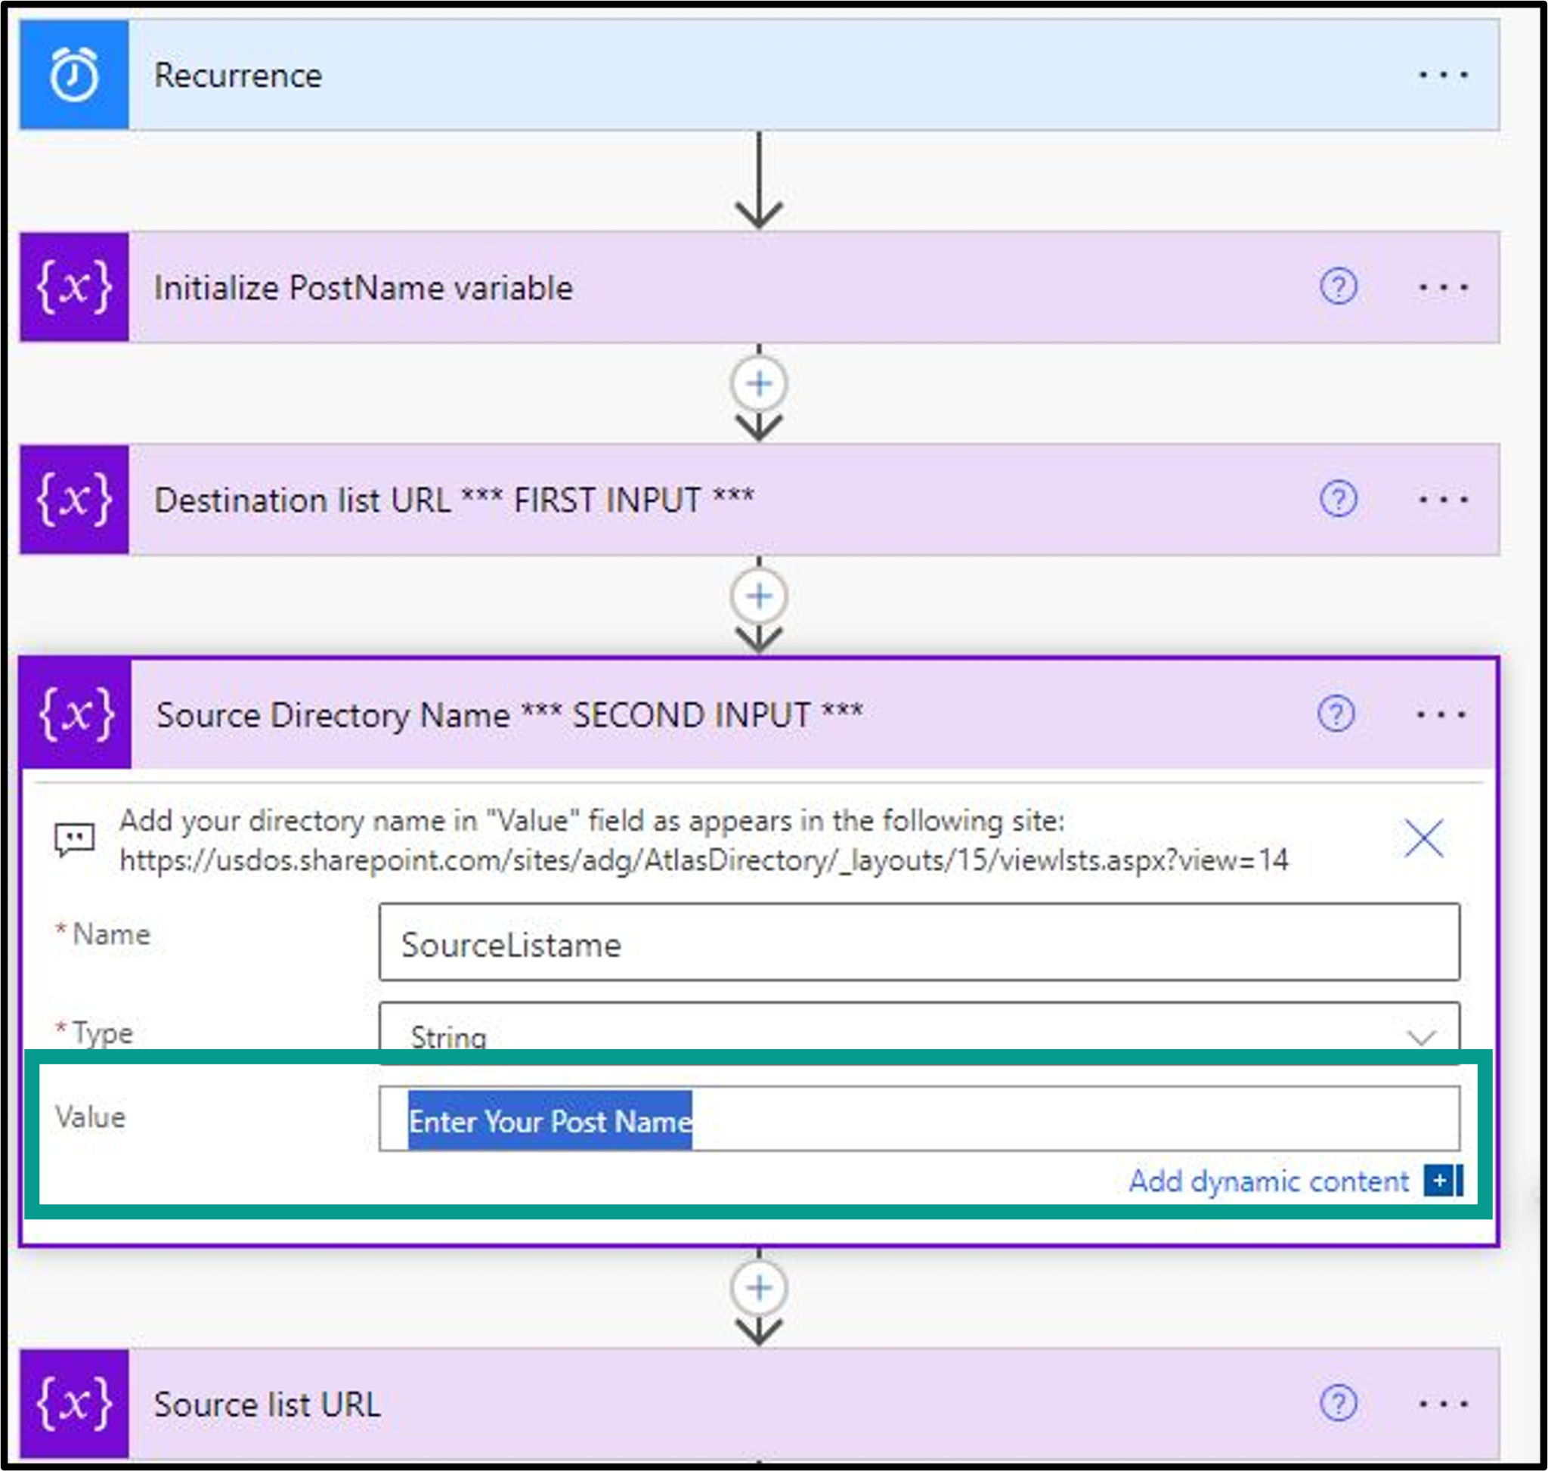

**Step 12**

Under **Source Directory Name > Value**, enter the name of your post.

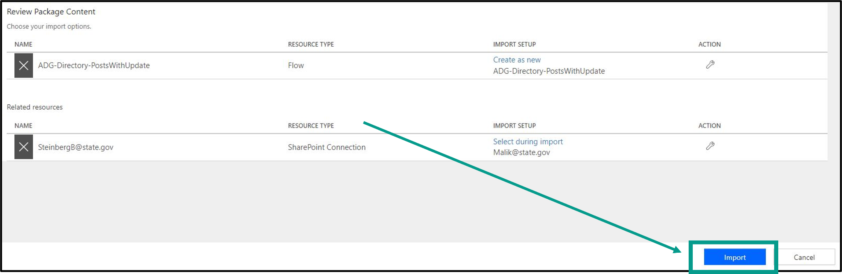

**Step 13**

Select the **Turn On** button and then click **Run**.

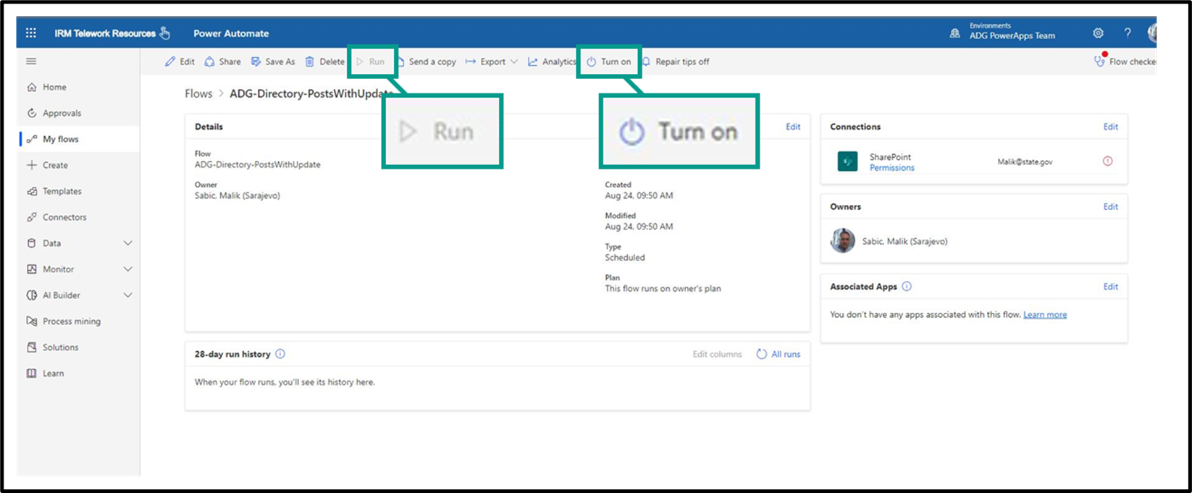

Your import is now complete!

