Okta Mobile App – First-time User Instructions

After you have enrolled in Okta Verify MFA, you can use a separate app – Okta Mobile -- to quickly and securely access your favorite DoS apps* directly from your phone.
(* Google FAN, myData, ServiceNow, FSiLearn, CRM, and many more)
If you prefer video instructions, go here.
1. On your smartphone (DoS or personal), download the “Okta Mobile” app (iOs link, Android link)

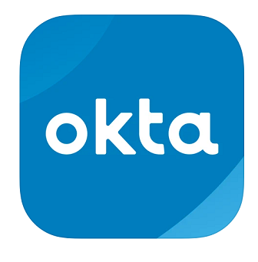
2.Sign-up using using state.okta.com as the “site name” and your OpenNet username and password.
3. Press “Sign In”
4. This will start the authentication process with Okta Verify MFA. You will see this screen:
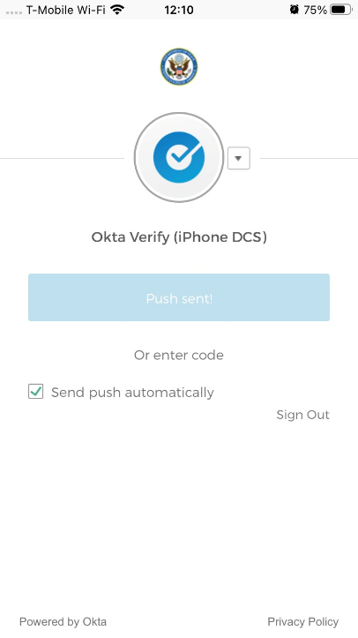
(Note: If the blue bar in the middle is darker and says Push!, then push it)
5.Then go to your Okta Verify app on your smartphone and you will see this:​​​​​​​
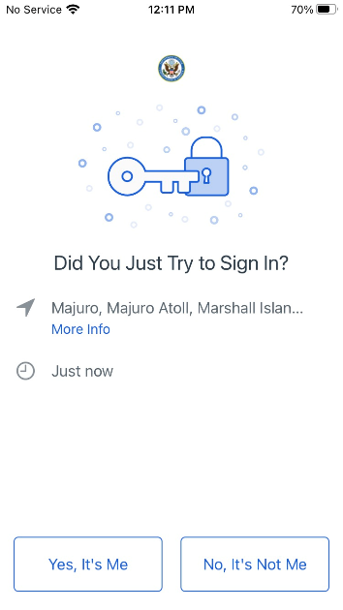
Press “Yes, it’s me.”

6.The Okta Mobile app will then ask you to enter a four-digit PIN. Enter and confirm it.

7.You now have access to your apps, protected by Okta.​​​​​​​​​​​​​Verify. Here is the mobile dashboard of apps.
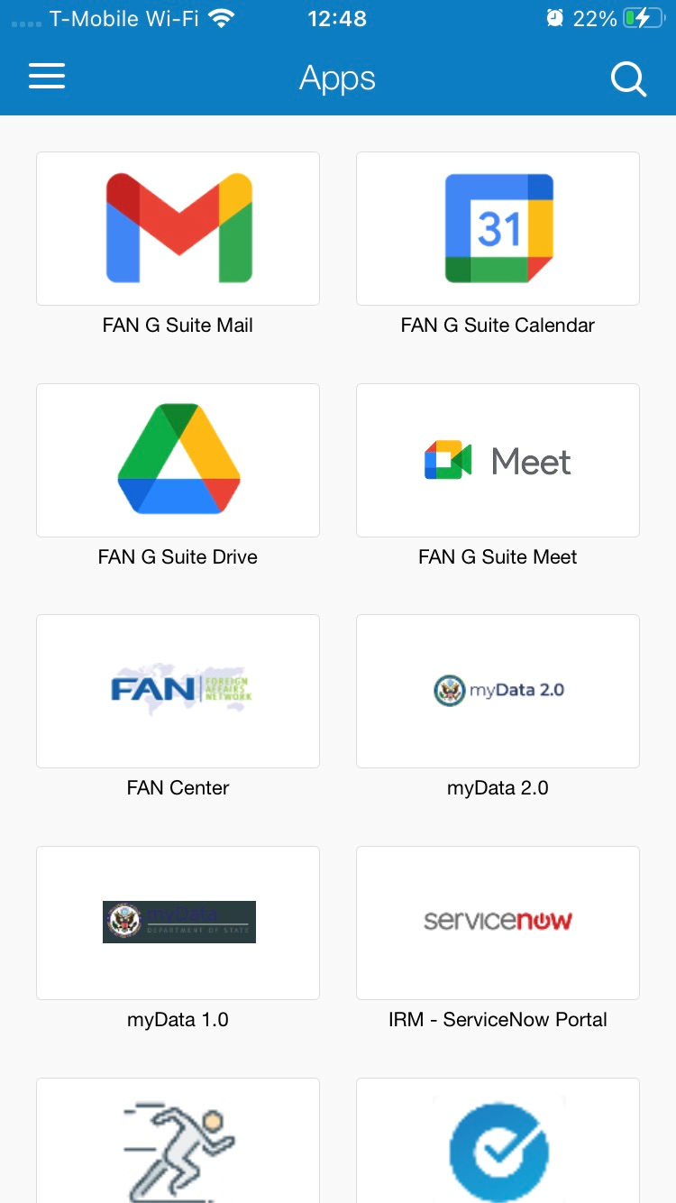

Having some other issue accessing apps though Okta?
Phone: (202) 647-2000
Email: ITServiceCenter@state.gov
Online: IT Services Online
Ask to have your ticket transferred to the Single Sign-On Okta Team (SE-ICAM)

Want to learn more about Okta? - Go to the State​ Enterprise Identity, Credential, and Access Management Program (SE-ICAM) sharepoint site or SE-ICAM's Diplopedia page on Okta access issues, here. If you have recently been issued a new phone and need to re-set your Okta Verify MFA, go here for instructions.

